Upload Image To IBM container

|  |  |
| --- | --- |
| Date | 18 November 2022 |
| Team Id | PNT2022TMI25340 |
| Project Name | Smart Fashion Recommender Application |

CREATING REPOSITORY IN IBM CLOUD

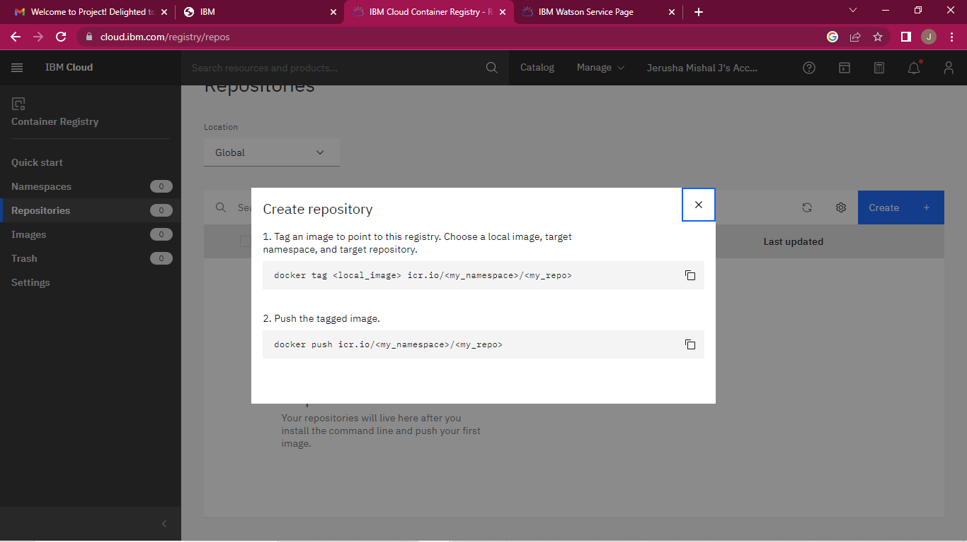

UPLOAD IMAGE TO IBM CONTAINER REGISTRY

